AIM
To design and deploy a cloud-based Property Buying & Rental System for Chennai city using Zoho Creator, demonstrating the concept of Software as a Service (SaaS).

PROCEDURE

- Login to Zoho Creator using your Zoho account.
- Create a new application → Select “Create from Scratch.”
- Name the Application: Chennai Property Portal.
  - Design Forms: Property Listing Form → Owner Name, Contact Number, Property Type (House/Flat/Land), Location (dropdown limited to Chennai areas), Price, For Sale/Rent.
  - Buyer/Renter Request Form → Name, Email, Phone, Preferred Location, Budget, Type (Buy/Rent).

  - Create Reports: Available Properties Report → Filter by type, location, and price.
  - Requests Report → List of buyers/renters with preferences.

  - Workflow Automation (Optional): Send an email notification to property owner when a request matches their listing.
  - Auto-generate a confirmation message for users after form submission.

- Publish the Application → Generate a web link so users in Chennai can access it online.
- Test the Application by adding sample property listings and making a rental/buy request.

OUTPUT
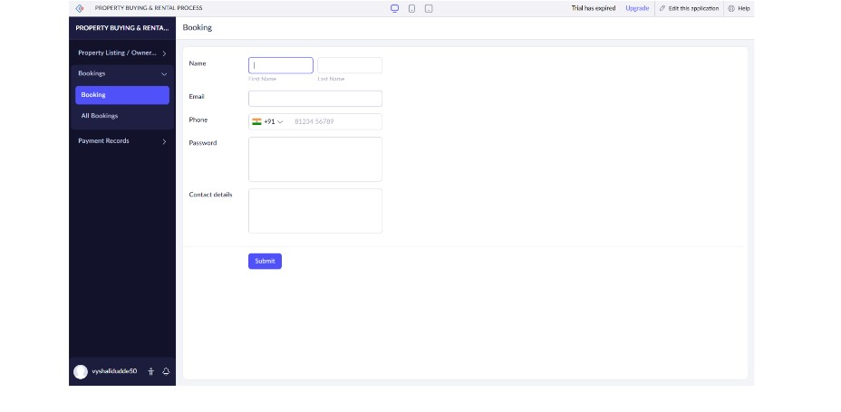
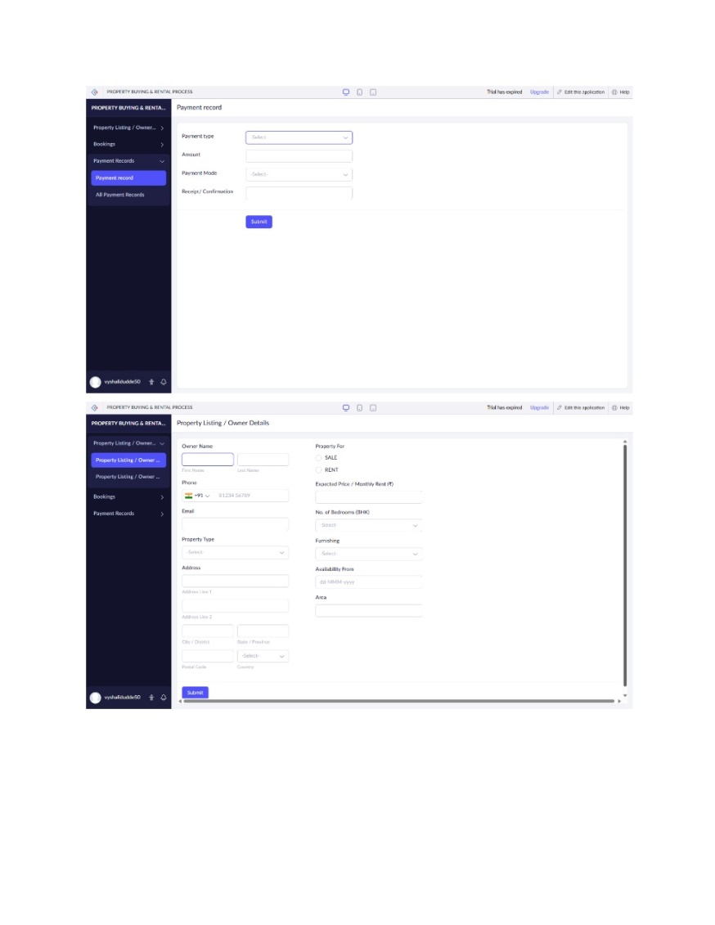
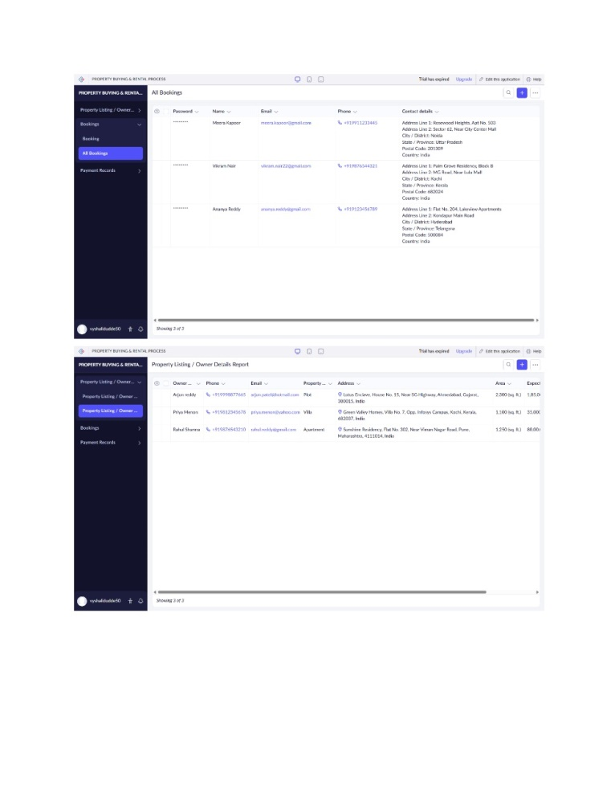

RESULT
Thus to deploy a cloud-based Property Buying & Rental System for Chennai city is implemented using Zoho software

